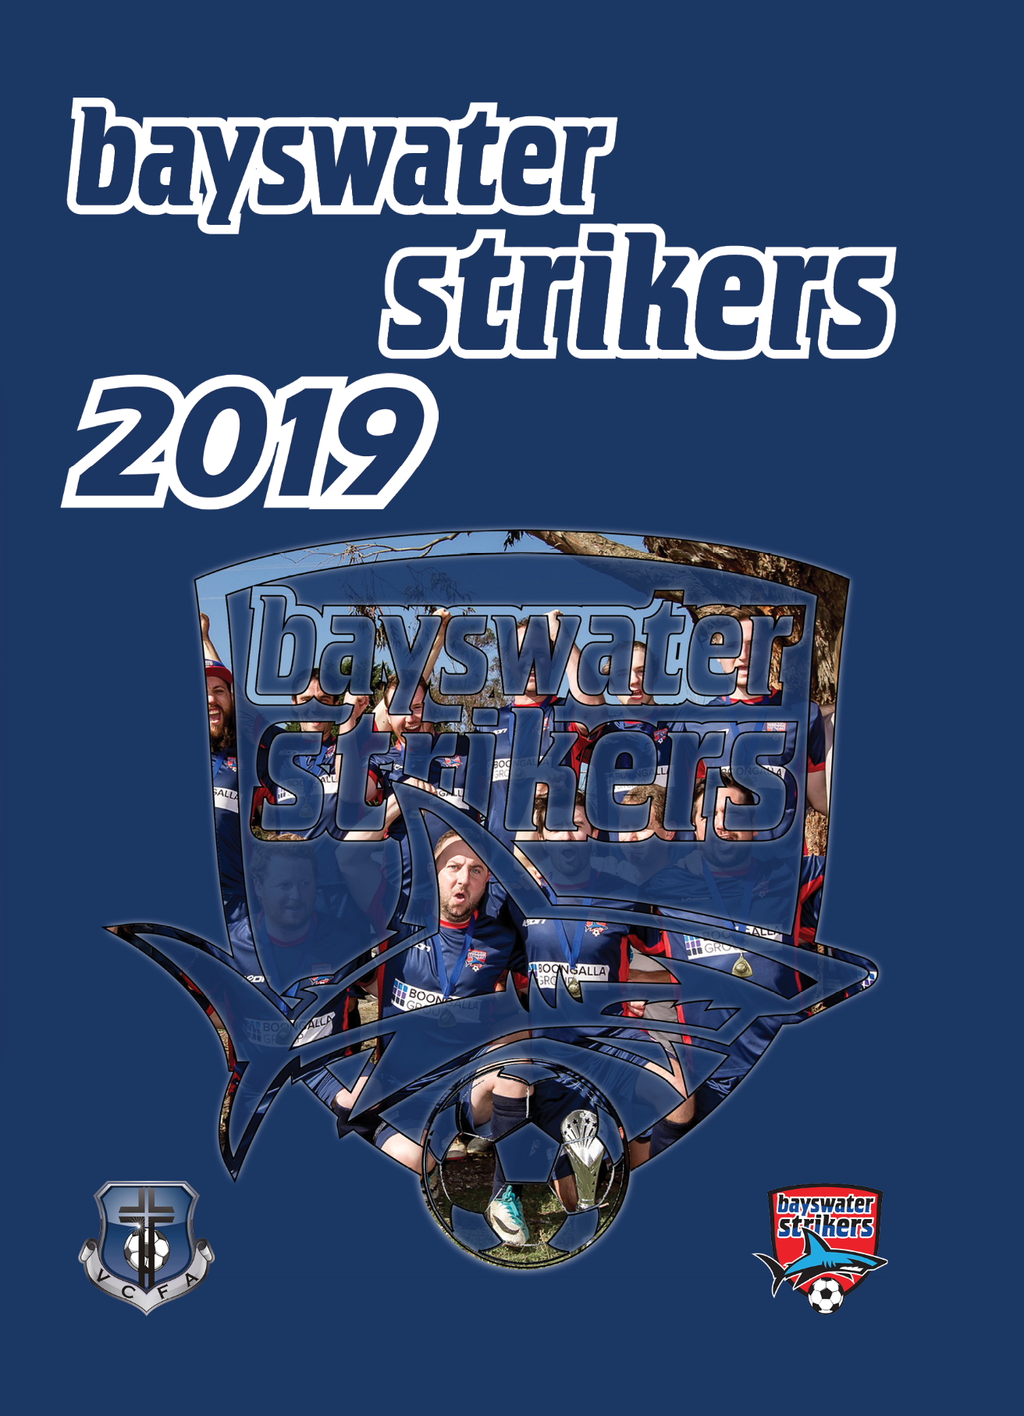

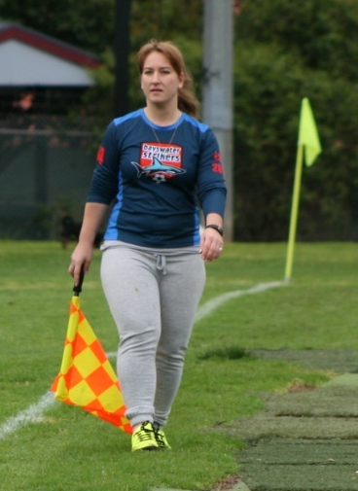
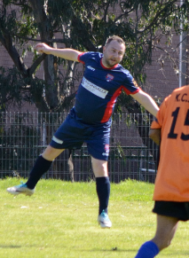
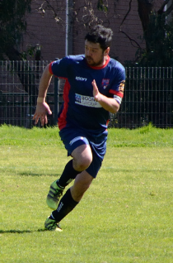
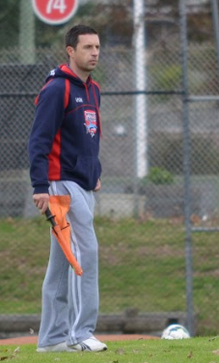
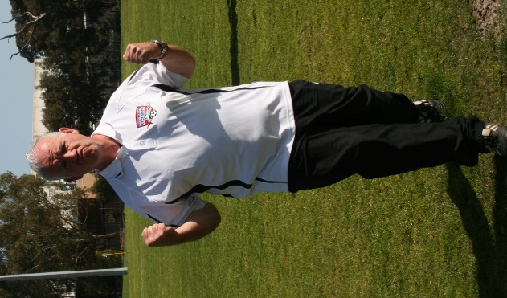
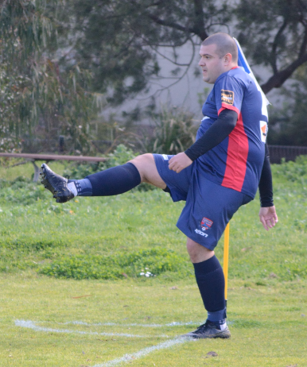
2019 Committee
A committee is organic rather than mechanical in its nature: it is not a structure but a plant. It takes root and grows, it flowers, wilts, and dies, scattering the seed from which other committees will bloom in their turn.

-C. Northcote Parkinson
We wish to say thank you to every member of our committee for the countless hours spent serving the Bayswater Strikers Soccer Club in 2019
President: Mark Eaton Vice President: Mark Murphy
Secretary: Eva Orlowski-Oliver Treasurer: Chris Woods
Sponsorship: Stephen Tiovonen Social: Paul Sanhueza

VCFA – Men’s Division 5

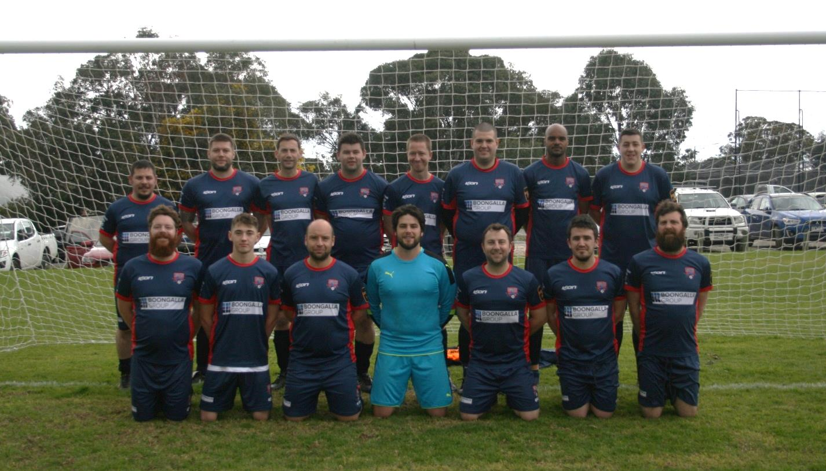

Back row: Liam Brimmer (Coach), Mark Ewington, Nicholas King, Christopher Muir, Matthew Foye,
Chris Woods, Andrew Davy, Mykl Van Egmond
Bottom Row: Hayden Connolly, Julian Pulford, William Clark, James Mason, Mark Eaton, Zachary Piper, Rick Connolly
Absent: Stuart Oliver, Ralston White

Results

Round 1 | Doncaster Rovers |  | 1 | : | 2 |  | Bayswater Strikers
Scorers: | L.Brimmer, M.Eaton
Votes: | M.Foye 5, C.Muir 3, N.King 2, M.Eaton 2
Round 2 | Berwick Spirit |  | 1 | : | 0 |  | Bayswater Strikers
Votes: | R.Beekman 6, N.King 2, H.Connolly 2, D.Smith 1, M.Foye 1
Round 3 | Lilydale Eagles |  | 1 | : | 0 |  | Bayswater Strikers
Votes: | H.Connolly 3, C.Woods 3, N.King 3, M.Foye 3
Round 4 | Maroondah United |  | 1 | : | 0 |  | Bayswater Strikers
Votes: | M.Foye 5, R.Beekman 4, H.Connolly 2, A.Davy 1
Round 5 | Knox Churches Fury |  | 6 | : | 0 |  | Bayswater Strikers
Votes: | M.Foye 6, C.Woods 2, R.White 2, H.Connolly 1, A.Davy 1
Round 6 | Yarra Valley |  | 0 | : | 0 |  | Bayswater Strikers
Votes: | M.Foye 5, C.Muir 5, J.Pulford 1, A.Davy 1
Round 7 | Bayswater Strikers |  | 3 | : | 4 |  | Eltham Intrepid
Scorers: | J.Bucedi 2, J.Pulford
Votes: | J.Bucedi 5, M.Foye 5, J.Pulford 1, S.Oliver 1
Round 8 | Donvale Cavaliers |  | 2 | : | 1 |  | Bayswater Strikers
Scorer:  Votes: | Z.Piper  M.Foye 6, N.King 2, C.Woods 2, Z.Piper 1, A.Davy 1
Round 9 | Bayswater Strikers |  | 1 | : | 3 |  | Monbulk Old Boys
Scorer:  Votes: | R.Connolly  M.Foye 4, R.Connolly 3, J.Bucedi 3, N.King 1, C.Muir 1
Round 10 | Bayswater Strikers |  | 1 | : | 1 |  | Doncaster Rovers
Scorer: | O.Goal
Votes: | R.Beekman 5, C.Muir 5, R.Connolly 1, M.Foye 1
Round 11 | Bayswater Strikers |  | 0 | : | 1 |  | Berwick Spirit
Votes: | P.Sanhueza 6, M.Foye 3, C.Muir 2, S.Oliver 1
Round 12 | Lilydale Eagles |  | 5 | : | 1 |  | Bayswater Strikers
Scorer:  Votes: | A.Davy  J.Mason 6, N.King 2, M.Foye 2, A.Davy 2
Round 13 | Bayswater Strikers |  | 3 | : | 1 |  | Maroondah United
Scorers:  Votes: | A.Davy 2, M.Eaton  J.Mason 6, A.Davy 4, M.Eaton 2
Round 14 | Knox Churches Fury |  | 3 | : | 0 |  | Bayswater Strikers
Votes: | C.Muir 4, C.Woods 3, S.Oliver 2, A.Davy 2, M.Foye 1
Round 15 | Bayswater Strikers |  | 0 | : | 2 |  | Yarra Valley
Votes: | C.Muir 3, M.Eaton 3, J.Pulford 2, R.Connolly 2, S.Oliver 1, M.Foye 1
Round 16 | Eltham Intrepid |  | 1 | : | 1 |  | Bayswater Strikers
Scorer: | A.Davy
Votes: | N.King 6, W.Clark 4, A.Davy 2
Round 17 | Bayswater Strikers |  | 5 | : | 2 |  | Donvale Cavaliers
Scorers: | J.Pulford 2, G.Brown, M.Adrian, C.Woods
Votes: | G.Brown 6, J.Pulford 2, N.King 2, R.Connolly 1, M.Foye 1
Round 18 | Bayswater Strikers | 1 |  | : |  | 1 |  | Monbulk Old Boys
Scorer: | M.Foye
Votes: | W.Parnell 6, H.Connolly 3, M.Foye 3

Arnold Visser Cup

Round of 16 | Bayswater Strikers  (BSSC win 2-0 on penalties) | 1 | : | 1 | Monbulk Rangers
Scorer: | J.Pulford
Quarter Final | Bayswater Strikers | 3 | : | 1 | Yarra Valley
Scorers: | S.Oliver 2, J.Pulford
Semi Final | Knox Churches Valour | 1 | : | 2 | Bayswater Strikers
Scorers: | C.Woods, S.Oliver
Final | Maroondah United  (MUSC win 3-2 on penalties) | 1 | : | 1 | Bayswater Strikers
Scorer: | J.Pulford

Final Standings

Division Five
 |  | P | W | D | L | GD | F | A | PTS
1 | Lilydale Eagles Reserves | 18 | 16 | 1 | 1 | 48 | 69 | 21 | 49
2 | Knox Churches Fury | 18 | 12 | 2 | 4 | 20 | 50 | 30 | 38
3 | Monbulk Old Boys | 18 | 11 | 3 | 4 | 30 | 53 | 23 | 36
4 | Berwick Spirit | 18 | 11 | 1 | 6 | 15 | 38 | 23 | 34
5 | Yarra Valley Reserves | 18 | 8 | 3 | 7 | -1 | 26 | 27 | 27
6 | Maroondah United 4ths | 18 | 6 | 5 | 7 | -3 | 35 | 38 | 23
7 | Donvale Cavaliers | 18 | 5 | 0 | 13 | -27 | 27 | 54 | 15
8 | Bayswater Strikers Thirds | 18 | 3 | 4 | 11 | -17 | 19 | 36 | 13
9 | Doncaster Rovers Thirds | 18 | 3 | 4 | 11 | -18 | 27 | 45 | 13
10 | Eltham Eagles Intrepid | 18 | 2 | 3 | 13 | -47 | 19 | 66 | 9

Award Winners

Best and Fairest: Matthew Foye
Runner Up Best and Fairest: Chris Muir
Top Goal Scorer: Andrew Davy (4)
Players Player: Nicholas King
Coaches Award: Stuart Oliver
Goal of the Season: Andrew Davy

Coach’s Report

I was delighted to take the coaching role of the thirds for 2019. Preseason kicked off earlier this year and I was confident that we would have a competitive squad for the year ahead. Most of the squad had returned after a difficult season in 2018 which was credit to the club and the environment that it brings.
With a few preseason games under our belt it was time for the competitive season to start. Our first game we recorded a win and the boys sung the song (with many trying to remember the words) with passion in true striker spirit. As the rounds went on, we were so close in many games, with the luck against us.
After round 8 we went into our first cup game. We played Monbulk from the league below us who had a prolific scoring record. We play a very good game against a young fast team. After 90 minutes we were locked at 1-1. Penalties it was. What happened at the shootout can only go down in ‘Onslow folk-law’ with Heshy saving all penalties and scoring for us to come away with the win and book a place in the quarter-final.
The following week it was back to business and we still were struggling to find the pot at the end of the rainbow. Round 10 we managed to get a valuable point against Doncaster after playing in almost complete darkness. It wasn’t until round 13 that we recorded our next win against Maroondah, it was a well fought win and set the tone for the remainder of the season.
Our next cup game we played Yarra Valley. We drew last time we played, and we knew this was going to be cracker of a game. This time it was Onslow (Heshy) on the park that came good. In the whole time I have known Heshy I cannot recall him heading home a goal let alone 2! As some may say it was all about the delivery. We came away 3-1 winners and it was a massive win for the boys. Onto the semi-final.
As we came to the pointy end of the season we needed to lift and avoid relegation. In the final rounds and pitches had been unplayable, and we had to perform 3 times in 8 days. The workload was huge and having to play our cup semi-final mid-week. The boys were up and about. The message was to finish the game in the 90 minutes. After a hard-fought game with the game locked at 1-1 and 10 minutes to go, we managed to put one of our many chances away and hope to finish the game. After giving a little territory and playing a little deeper the pressure was on. When the final whistle went the boys were ecstatic know all the hard work had booked them a place in the cup final.
Back to the league. With 3 rounds to go and playing catch up, the boys pulled off some good results with a 1-1 draw away to Eltham, and a season saving 5-2 win at home against Donvale. It all came down to the last game of the season. We needed a draw against Monbulk who were still in the hunt to finish runner-up in the league. Again, the boys came to play and put in a great shift and finally we had a little luck pulling off a 1-1 draw after defending heavily for the last 10 minutes. A fantastic effort, that when we needed to stand up, we did. We managed to avoid relegation by goal difference and the Maroondah win been the defining game. Congratulations boys on staying in Division 5 for season 2020.
Now onto the big dance, the Cup Final against Maroondah. It was something the boys had worked hard for and deserved to be there. For me it was a difficult selection process, having to fit 17 into 16. Much credit to Will Clark who was picked in the final 16, however was crook the night before and made the call to sit out. Kudos for your honesty.
The game was going to be won by whoever could finish their chances. The first half was played out with Bayswater having created a lot of the chances in front of goal. The half ended at 0-0. After some encouraging words from the boys we went out to get the job done, 15 minutes in we found ourselves 1-0 down and chasing the game. It was time for the boys to lift and after creating many chances we managed to peg one back with 15 to go. There were chances by both teams to finish the game off, however the ref blew for full time. Onto penalties it was.
Bayswater started the shoot-out. This time we didn’t have the luck on our side, and fell short losing the shoot-out 2-3. As I said after the game, the boys deserve a thousand pats on the back for not only making to the cup final but forcing it to penalties after to going 1-0 down.

Congratulations boys on an enjoyable season and thanks for allowing me to coach you week in and out.
Special thanks to the committee, coaching staff, volunteers on game day and Dee who made sure when were able to train, we left with our bellies full.

Brim

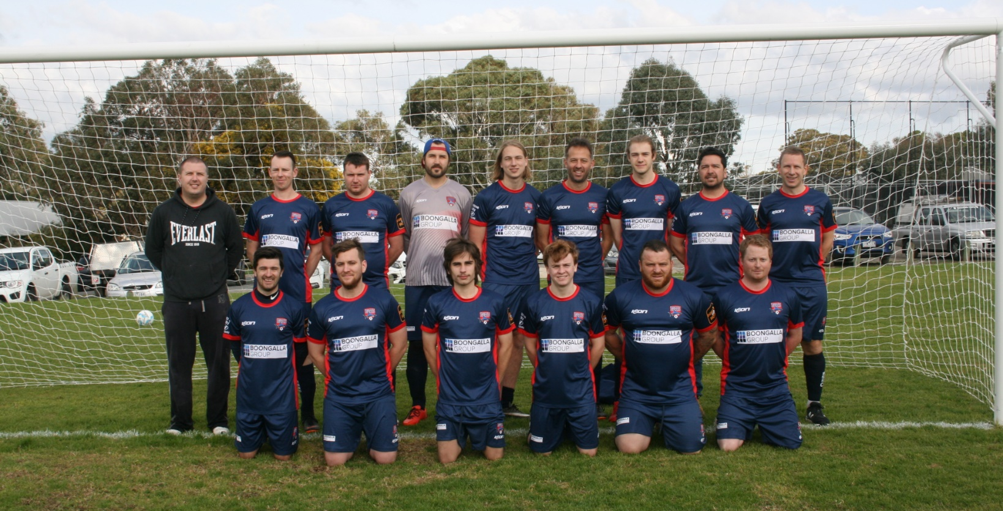

VCFA – Men’s Reserves

Back row: Emlyn Almrott (Coach), Darren Hamilton-Morris, Joseph Keegan, Rick Beekman, Mitchell Lacey, Jeff Wortman,
Daniel Smith, Paul Sanhueza, Raymond Ternes,
Bottom Row: James Sporton, William Parnell, Cooper Armstrong, Darcy Cleal, John Bucedi, Ben Crawford
Absent: Glen Brown, Anant Mattoo, Ronan Glen, Corey Flanagan,
Ryan Shellard, Stephen Toivonen, Ray Ternes, Edward Hammond
Front row: Ben Crawford, Johnny Bucedi, Matthew Puts, James Sporton, Pedrum Najafzadeh, Liam Brimmer (Coach)

Results

Round 1 | Blackburn NewHope | 1 | : | 1 | Bayswater Strikers
Scorer:  Votes: | G.Brown  A.Karg 5, R.Ternes 5, J.Wortman 1, J.Mason 1
Round 2 | FC CityLife | 5 | : | 0 | Bayswater Strikers
Votes: | R.Ternes 6, J.Mason 4, J.Keegan 2
Round 3 | Bayswater Strikers | 0 | : | 3 | Eltham Eagles
Votes: | A.Karg 5, P.Sanhueza 4, J.Wortman 2, R.Ternes 1
Round 4 | Knox Churches Strikers | 4 | : | 0 | Bayswater Strikers
Votes: | A.Karg 6, J.Wortman 2, W.Parnell 2, J.Mason 1, D.Smith 1
Round 5 | Whitehorse United | 1 | : | 2 | Bayswater Strikers
Scorers: | D.Cleal, J.Wortman
Votes: | W.Parnell 5, J.Sporton 3, D.Smith 2, J.Wortman 2
Round 6 | Berwick Churches | 1 | : | 0 | Bayswater Strikers
Votes: | J.Keegan 5, A.Karg 3, R.Ternes 2, J.Mason 2
Round 7 | Bayswater Strikers | 2 | : | 4 | Mooroolbark
Scorers: | A.Brookes, G.Brown
Votes: | J.Sporton 4, A.Mattoo 3, R.Ternes 3, E.Chandler 1, P.Sanhueza 1
Round 8 | Donvale | 2 | : | 2 | Bayswater Strikers
Scorers: | E.Chandler, J.Wortman
Votes: | C.Flanagan 4, B.Crawford 3, J.Wortman 3, E.Chandler 1, D.Smith 1
Round 9 | Bayswater Strikers | 2 | : | 5 | Maroondah United
Scorers: | O.Goal, D.Cleal
Votes: | J.Wortman 5, P.Sanhueza 3, D.Cleal 2, C.Flanagan 1, A.Mattoo 1
Round 10 | Bayswater Strikers | 0 | : | 3 | Blackburn NewHope
Votes: | J.Sporton 5, J.Wortman 3, W.Parnell 3, D.Cleal 1
Round 11 | FC CityLife | 1 | : | 0 | Bayswater Strikers
Votes: | W.Parnell 6, C.Armstrong 2, M.Lacey 2, B.Crawford 2
Round 12 | Eltham Eagles | 1 | : | 1 | Bayswater Strikers
Scorer: | J.Bucedi
Votes: | J.Keegan 5, W.Parnell 3, J.Bucedi 2, R.Beekman 1, B.Crawford 1
Round 13 | Bayswater Strikers | 0 | : | 2 | Knox Churches Strikers
Votes: | J.Wortman 3, W.Parnell 3, R.Ternes 3, D.Smith 2, R.Beekman 1
Round 14 | Whitehorse United | 3 | : | 0 | Bayswater Strikers
Votes: | W.Parnell 3, J.Keegan 3, R.Ternes 2, B.Crawford 2, E.Chandler 1, R.Beekman 1
Round 15 | Bayswater Strikers | 0 | : | 2 | Berwick Churches
Votes: | W.Parnell 5, J.Sporton 5, A.Mattoo 2
Round 16 | Mooroolbark | 3 | : | 4 | Bayswater Strikers
Scorers: | J.Wortman 2, J.Bucedi 2
Votes: | J.Bucedi 5, J.Wortman 3, A.Mattoo 2, J.Keegan 1, R.Beekman 1
Round 17 | Bayswater Strikers | 1 | : | 1 | Donvale
Scorer: | R.Glen
Votes: | W.Parnell 6, C.Armstrong 4, R.Glen 2
Round 18 | Maroondah United | 5 | : | 0 | Bayswater Strikers
Votes: | P.Sanhueza 6, C.Human 4, J.Keegan 2

Presidents Shield
Round of 16 | Bayswater Strikers | 3 | : | 2 | Whitehorse United
Scorer: | A.Brookes, J.Wortman, B.Crawford
Quarter Final | Bayswater Strikers | 2 | : | 1 | Moonee Valley
Scorers: | M.Edwards 2
Semi Final | Monbulk Rangers | 1 | : | 2 | Bayswater Strikers
Scorers: | J.Bucedi, M.Eaton
Final | Knox Churches Glory | 2 | : | 3 | Bayswater Strikers
Scorer: | M.Edwards, J.Wortman, J.Bucedi

Final Standings

Premier League Reserves
 |  | P | W | D | L | GD | F | A | PTS
1 | Berwick Reserves | 18 | 14 | 2 | 2 | 30 | 44 | 14 | 44
2 | KCSC Strikers | 18 | 13 | 2 | 3 | 34 | 57 | 23 | 41
3 | FC CityLife B | 18 | 11 | 4 | 3 | 22 | 42 | 20 | 37
4 | Eltham Eagles Reserves | 18 | 9 | 2 | 7 | 11 | 43 | 32 | 29
5 | BNFC Neroverdi | 18 | 8 | 5 | 5 | 5 | 31 | 26 | 29
6 | Whitehorse United Reserves | 18 | 5 | 5 | 8 | -6 | 33 | 39 | 20
7 | Mooroolbark Warriors | 18 | 6 | 2 | 10 | -13 | 32 | 45 | 20
8 | Donvale Reserves | 18 | 5 | 2 | 11 | -25 | 23 | 48 | 17
9 | Bayswater Strikers Reserves | 18 | 2 | 4 | 12 | -32 | 15 | 47 | 10
10 | Maroondah Utd Reserves | 18 | 3 | 0 | 15 | -26 | 30 | 56 | 9

Award Winners

Best and Fairest: Will Parnell
Runner Up Best and Fairest: Jeff Wortman
Top Goal Scorer: Jeff Wortman (4)
Players Player: Paul Sanhueza
Coaches Award: Will Parnell
Goal of the Season: Johnny Bucedi

Coach’s Report

This year has gone pretty much how I thought it would go. The focus was on growing the younger player’s abilities and developing them on how football should be played. To do this I was lucky enough to have some older more experienced boys leading the way and to help pass the message across when on the field.
Just like any growth, there were times where we held our own against the top teams and there were times to forget, but we will remember the season because of our triumph in the cup.
Thank you to the committee, Supporters, coaches and the players. The support and patience you have shown over the past 12 months it has been great. I hope that we are all back next January to start it all over again.
Emlyn

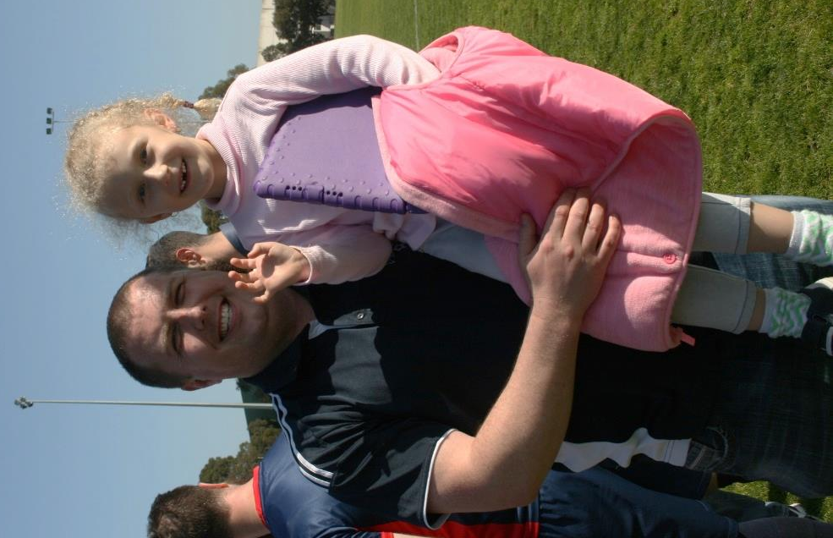

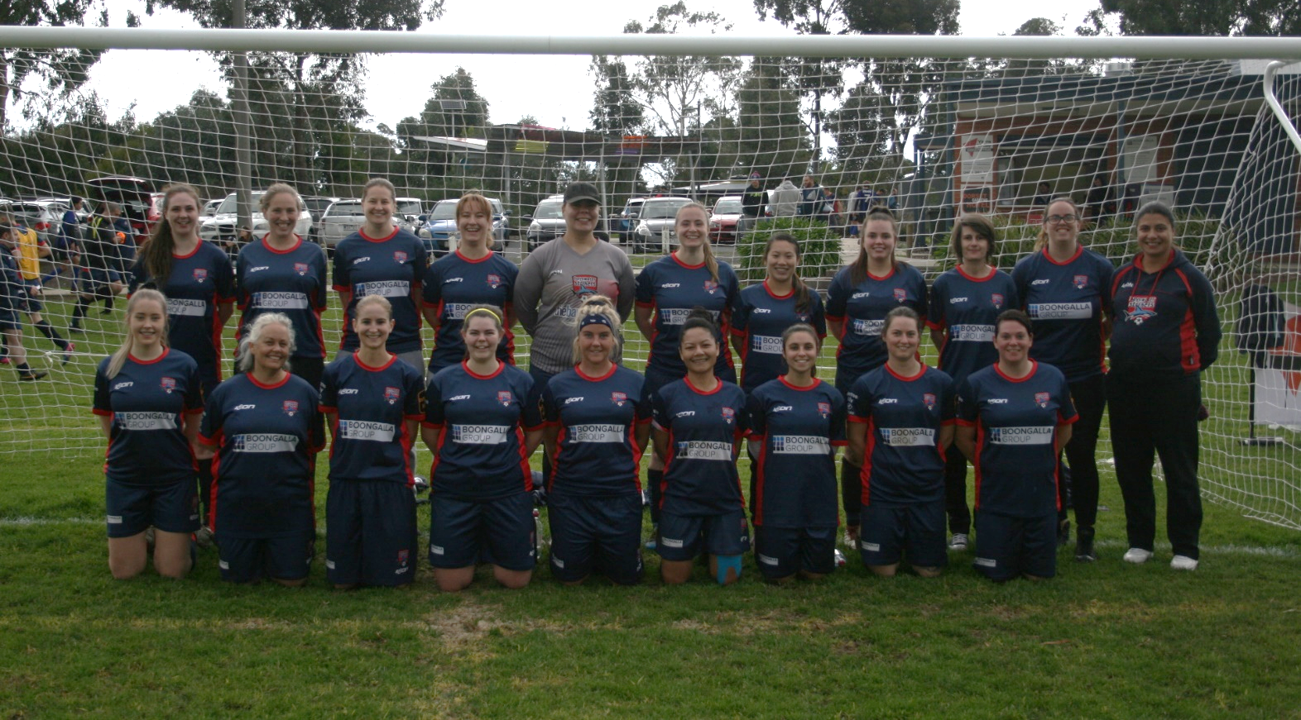

VCFA – Women’s Premier

Back row: Jessie Toogood, Heidi D’Urso, Anne-Marie Ternes, Eva Orlowski-Oliver, Sally Sherman (Coach),
Loran Keegan, Phuong Chandler, Sarah McCrae, Laura Croft, Samantha Sumsion, Veronica Castro Toivonen
Front Row: Cherokee Lyall, Margaret Awrey, Lani Hallam, Kathleen Mellahn, Jessica Murphy,
Rotha Vinh, Ioanna Joanna Fitopoulos, Tamara Petry, Lisa Kennedy.
Absent: Jilliam Gommers, Jodie Almrott

Results

Round 1 | FC CityLife B | 1 | : | 4 | Bayswater Strikers
Scorers:  Votes: | A.Ternes 2, A.Anyieth, H.D’Urso  A.Ternes 5, A.Anyieth 5, H.D’Urso 1, J.Toogood 1
Round 2 | FC CityLife | 3 | : | 1 | Bayswater Strikers
Scorers: | A.Ternes
Votes: | R.Vinh 3, A.Ternes 3, H.D’Urso 2, L.Kennedy 2, L.Keegan 1, S.Sumsion 1
Round 3 | Knox Ladies Force | 10 | : | 0 | Bayswater Strikers
Votes: | L.Hallam 5, T.Petry 3, S.Sherman 3, P.Chandler 1
Round 4 | Blackburn NewHope | 6 | : | 0 | Bayswater Strikers
Votes: | E.Orlowski-Oliver 3, H.D’Urso 3, P.Chandler 2, M.Awrey 2, R.Vinh 1, L.Hallam 1
Round 5 | Berwick Churches | 9 | : | 1 | Bayswater Strikers
Scorers: | J.Fitopoulos
Votes: | J.Fitopoulos 5, A.Ternes 4, H.D’Urso 2, L.Kennedy 1
Round 6 | Bayswater Strikers | 9 | : | 2 | St Hilarys
Scorers: | J.Fitopoulos 2, H.D’Urso 2, A.Ternes 2, L.Keegan, R.Vinh, L.Hallam
Votes: | J.Toogood 3, L.Hallam 3, M.Awrey 2, J.Fitopoulos 2, P.Chandler 1, E.Orlowski-Oliver 1
Round 7 | Croydon City Arrows | 5 | : | 0 | Bayswater Strikers
Votes: | R.Vinh 3, A.Ternes 3, C.Lyall 2, J.Almrott 2, S.Sherman 1, H.D’Urso 1
Round 8 | Monbulk | 0 | : | 1 | Bayswater Strikers
Scorers: | A.Ternes
Votes: | A.Ternes 3, H.D’Urso 3, J.Fitopoulos 2, S.Sherman 2, P.Chandler 1, S.Sumsion 1
Round 9 | Bayswater Strikers | 0 | : | 4 | FC CityLife
Votes: | S.Sherman 6, R.Vinh 2, H.D’Urso 2, L.Keegan 1, A.Ternes 1
Round 10 | Knox Ladies Force | 3 | : | 0 | Bayswater Strikers
Votes: | H.D’Urso 3, A.Ternes 3, R.Vinh 2, S.Sherman 2, T.Petry 1, J.Toogood 1
s
Round 11 | Bayswater Strikers | 4 | : | 3 | Blackburn NewHope
Scorers: | L.Keegan 3, A.Ternes
Votes: | L.Keegan 6, H.D’Urso 4, L.Hallam 1, S.Sherman 1
Round 12 | Berwick Churches | 3 | : | 0 | Bayswater Strikers
Votes: | Forfeit
Round 13 | Bayswater Strikers | 2 | : | 3 | St Hilary’s
Scorers: | S.Sumsion 2
Votes: | R.Vinh 5, S.McCrae 3, L.Hallam 3, J.Toogood 1
Round 14 | Bayswater Strikers | 3 | : | 5 | Croydon City Arrows
Scorers: | J.Fitopoulos 2, L.Keegan
Votes: | J.Fitopoulos 3, L.Keegan 3, R.Vinh 2, S.Sumsion 2, J.Gommers 1, C.Lyall 1
Round 15 | Bayswater Strikers | 0 | : | 3 | Monbulk
Votes: | J.Fitopoulos 5, R.Vinh 3, K.Mellahn 2, J.Murphy 1, C.Lyall 1
Round 16 | FC CityLife | 5 | : | 0 | Bayswater Strikers
Votes: | L.Kennedy 3, J.Fitopoulos 3, S.Sherman 3, R.Vinh 2, S.McCrae 1
Round 17 | Knox Ladies Force | 9 | : | 0 | Bayswater Strikers
Votes: | J.Gommers 4, L.Keegan 3, A.Ternes 2, S.Sherman 2, J.Murphy 1
Round 18 | Blackburn NewHope | 1 | : | 1 | Bayswater Strikers
Scorer: | S.McCrae
Votes: | A.Ternes 4, S.McCrae 4, J.Toogood 3, C.Lyall 1
Round 19 | Bayswater Strikers | 0 | : | 2 | Berwick Churches
Votes: | C.Lyall 5, A.Ternes 3, L.Keegan 2, S.Sherman 2
Round 20 | St Hilary’s | 2 | : | 1 | Bayswater Strikers
Scorer: | L.Keegan
Votes: | L.Keegan 5, L.Kennedy 4, C.Lyall 2, E.Orlowski-Oliver 1
Round 21 | Bayswater Strikers | 0 | : | 4 | Croydon City Arrows
Votes: | J.Gommers 5, S.McCrae 4, J.Toogood 3
Award Winners

Best and Fairest: Anne-Marie Ternes
Runner Up Best and Fairest: Chanrotha Vinh
Top Goal Scorer: Anne-Marie Ternes (7)
Players Player: Jessie Toogood
Goal of the Season: Lorna Keegan
Final Standings
Premier League (Women)
 |  | P | W | D | L | GD | F | A | PTS
1 | Berwick United Women | 21 | 20 | 1 | 0 | 70 | 85 | 15 | 61
2 | FC Citylife Women | 21 | 16 | 0 | 5 | 53 | 75 | 22 | 48
3 | KCSC Ladies Force | 21 | 13 | 1 | 7 | 54 | 91 | 37 | 40
4 | Croydon City SC Women | 21 | 13 | 0 | 8 | 24 | 67 | 43 | 39
5 | Monbulk Kookaburras | 21 | 8 | 0 | 13 | -6 | 31 | 37 | 24
6 | BNFC Phoenix | 21 | 5 | 2 | 14 | -57 | 42 | 99 | 17
7 | Bayswater Strikers Women | 21 | 4 | 1 | 16 | -56 | 26 | 82 | 13
8 | St Hilarys Ladies | 21 | 4 | 1 | 16 | -70 | 25 | 95 | 13

Coach’s Report

This season would have to go down as hands down the most joyful, chaotic and disruptive season yet. From having 21 players down to not enough to field a team at one point, it's the baysie spirit that never changed once. We welcomed new member to the team, seen some return from some time off and seen some go due to injury and pregnancy. I would like to wish the Vinh/Croft family a speedy recovery with both their season ending injuries and make sure you take the time to heal so you are back on the field ready for another awesome season. To H and Fang..... well played ;) . It was awesome to see how super keen Sarah was coming back to play after just having a kiddo and we hope to see Ronnie back next season. We are definitely building a super team in 2035. Hope to see you back of the field too Ash ;) I would also publicly acknowledge a team mate who has had a really rough time but week in and week out she has turned up got the job done and put the team first. Nemo you are one awesome person and are the poster girl for grit and determination!
The games did not always go our way and the team copped a few Sally sprays at half time but the girls were always ready to give their all and more importantly support their team mates. Next season though all off field catch up times will be strictly supervised with a curfew due to #catgate

Sally

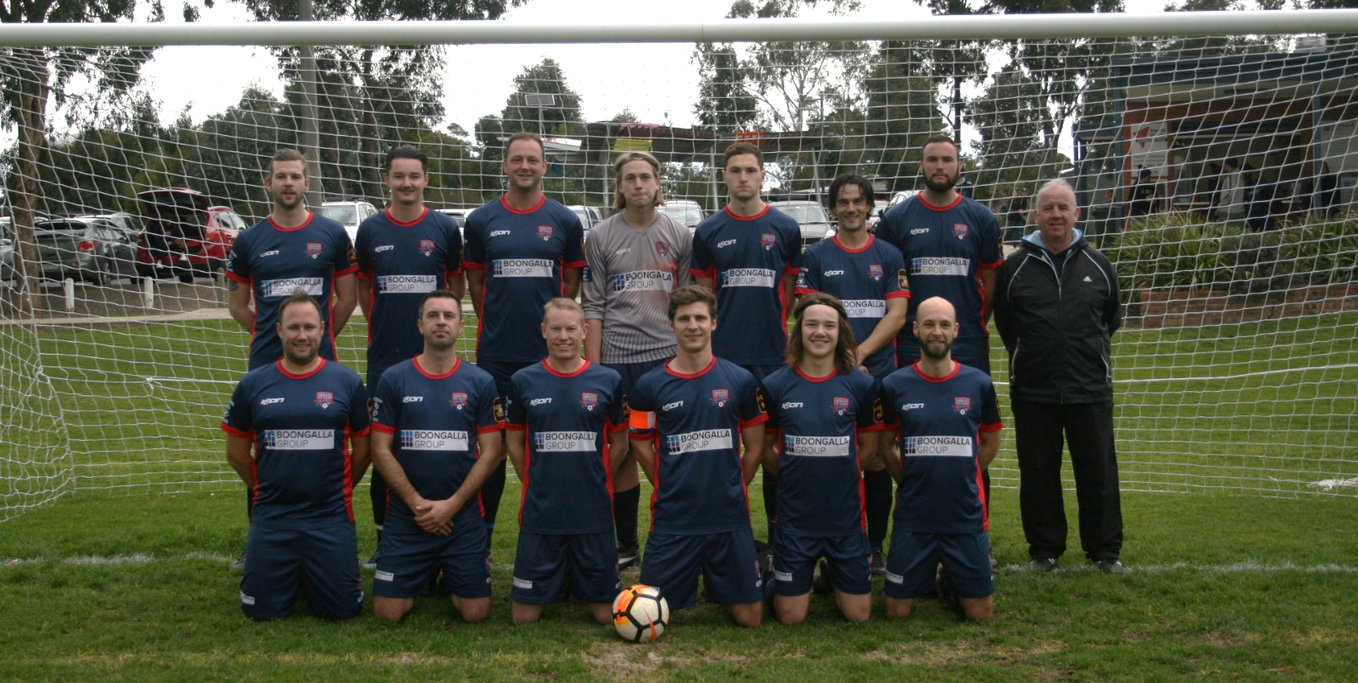

VCFA – Men’s Premier
Back row: Corbin Vetter, Josh Barmby, Richard Brown, Mitchell Lacey, Max Edwards, Steven D’Urso,
Mark Ellison, Mark Murphy (Coach)
Front row: Adam Karg, Stephen Toivonen, Chris Jaques, Kyle Chandler, Zach Barmby, Andrew Dodson
Absent: George Stanojevic,

Results

Round 1 | Blackburn NewHope | 3 | : | 1 | Bayswater Strikers
Scorer:  Votes: | Z.Barmby  S.D’Urso 6, G. Stanojevic 2, C.Jaques 2, K.Chandler 2
Round 2 | FC CityLife | 2 | : | 2 | Bayswater Strikers
Scorers: | E.Chandler, K.Chandler
Votes: | S.D’Urso 5, M.Edwards 5, C.Jaques 1, M.Ellison 1
Round 3 | Bayswater Strikers | 0 | : | 6 | Eltham Eagles
Votes: | K.Chandler 5, R.Brown 3, A.Dodson 3, Z.Barmby 1
Round 4 | Knox Churches Force | 3 | : | 0 | Bayswater Strikers
Votes: | S.D’Urso 6, K Chandler 3, C.Jaques 2, S. Fisher 1
Round 5 | Whitehorse United | 3 | : | 4 | Bayswater Strikers
Scorers: | G.Stanojevic 2, K.Chandler, C.Vetter
Votes: | G. Stanojevic 4, R Brown 3, S D’Urso 2, J.Barmby 2, M.Edwards 1
Round 6 | Berwick United | 1 | : | 0 | Bayswater Strikers
Votes: | S.D’Urso 6, R.Brown 3, C.Jaques 2, A.Dodson 1
Round 7 | Bayswater Strikers | 1 | : | 2 | Mooroolbark
Scorer: | M.Edwards
Votes: | S.D’Urso 3, R.Brown 3, M.Edwards 2, C.Jaques 2, Z.Barmby 1, J.Barmby 1
Round 8 | Donvale Cannons | 4 | : | 3 | Bayswater Strikers
Scorers: | J.Barmby, A.Dodson, K.Chandler
Votes: | A.Dodson 6, Z.Barmby 2, M.Ellison 2, K.Chandler 1, S.D’Urso 1
Round 9 | Bayswater Strikers | 4 | : | 3 | Maroondah United
Scorers: | S.D’Urso 2, J.Barmby 2
Votes: | J.Barmby 6, S.D’Urso 3, M.Edwards 3
Round 10 | Bayswater Strikers | 3 | : | 2 | Blackburn NewHope
Scorers: | M.Edwards, O.Goal
Votes: | M.Edwards 3, J.Barmby 3, R.Brown 2, C.Jaques 2, S.D’Urso 2
Round 11 | Bayswater Strikers | 1 | : | 0 | FC CityLife
Scorers: | K.Chandler
Votes: | S.D’Urso 5, K.Chandler 5, M.Ellison 1, A.Dodson 1
Round 12 | Eltham Eagles | 2 | : | 2 | Bayswater Strikers
Scorers: | K.Chandler, S.D’Urso
Votes: | M.Edwards 6, Z.Barmby 2, R.Brown 2, A.Dodson 2
Round 13 | Bayswater Strikers | 1 | : | 1 | Knox Churches Force
Scorers: | K.Chandler
Votes: | S.D’Urso 6, J.Barmby 3, C.Jaques 3
Round 14 | Whitehorse United | 3 | : | 1 | Bayswater Strikers
Scorers: | E.Almrott
Votes: | M.Edwards 4, R.Brown 3, J.Sporton 3, C.Vetter 2
Round 15 | Bayswater Strikers | 1 | : | 3 | Berwick United
Scorers: | K. Chandler
Votes: | K.Chandler 5, Z. Barmby 3, A.Dodson 2, J.Barmby 1, R.Brown 1
Round 16 | Mooroolbark | 2 | : | 0 | Bayswater Strikers
Votes: | A.Dodson 4, M.Ellison 3, R.Brown 3, C.Jaques 2
Round 17 | Bayswater Strikers | 3 | : | 0 | Donvale Cannons
Scorers: | K. Chandler 2, A.Dodson
Votes: | K.Chandler 6, A.Dodson 4, R.Brown 2
Round 18 | Bayswater Strikers | 2 | : | 4 | Maroondah United
Scorers: | K.Chandler, M.Byrnes
Votes: | R.Brown 6, K.Chandler 2, C.Jaques 2, C.Vetter 1, M.Byrnes 1

Parry Shield

Round of 16 | Bayswater Strikers | 1 | : | 2 | Whitehorse United
Scorer: | K. Chandler

Award Winners

Best and Fairest: Steven D’Urso
Runner Up Best and Fairest: Richard Brown
Top Goal Scorer: Kyle Chandler (10)
Players Player: Richard Brown & Steven D’Urso
Goal of the Season: Josh Barmby
Final Standings

Premier League (Seniors)
 |  | P | W | D | L | GD | F | A | PTS
1 | Mooroolbark Knights | 18 | 13 | 4 | 1 | 43 | 72 | 29 | 43
2 | KCSC Force | 18 | 11 | 5 | 2 | 35 | 61 | 26 | 38
3 | Berwick United | 18 | 9 | 5 | 4 | 19 | 41 | 22 | 32
4 | BNFC Lupi | 18 | 9 | 3 | 6 | 2 | 37 | 35 | 30
5 | Maroondah Utd | 18 | 7 | 3 | 8 | -14 | 35 | 49 | 24
6 | FC CityLife | 18 | 6 | 5 | 7 | -2 | 32 | 34 | 23
7 | Whitehorse United SC | 18 | 7 | 2 | 9 | -12 | 35 | 47 | 23
8 | Bayswater Strikers | 18 | 5 | 3 | 10 | -15 | 29 | 44 | 18
9 | Donvale Cannons | 18 | 3 | 4 | 11 | -32 | 22 | 54 | 13
10 | Eltham Eagles | 18 | 1 | 4 | 13 | -24 | 22 | 46 | 7

Coach’s Report

First of all a massive thank you to the President, the Bayswater committee & all of the people who make our club a great place to be, without you all we are nothing, together we can do anything.
On the football front - To Sally & the girls team a tough season with some new faces, but the girls never lost that Bayswater spirit & battled hard in every contest, to Sally who always kept a smile on her face & a positive word much admiration for the job you do, well done.
The thirds lead by Liam Brimmer - The last game of the season a heartbreaking loss on penalties in the cup final but the thirds won many admirers during the season. Coaching the thirds is probably the most difficult gig in the club but Liam accepted the challenge head on as he always does at Bayswater, he moulded his troops greatly & kept them in the 5th division with some great results especially in the last couple of rounds, my respect for his work with the boys is beyond words. Well done Liam great work.
Reserves - Emlyn Almrott took over the reserves & a massive thanks to him for the job he did, he always tried to play attractive football ideally he would of likened it to Liverpool. He took the reserves to the cup final & brought home Bayswater’s first silverware in the VCFA after a pulsating final where Baysy always make it interesting & many hearts were in their mouths with 10 minutes left, Emlyn as usual kept cool & guided the boys home, Emlyn’s

honesty is unwavering & his knowledge of the game second to none, he really made the reserves accountable, to Emlyn thanks for the season we
didn't always see eye to eye but that's football we will always remain friends well done mate.
Seniors - Thank you first of all to the senior’s boys in every game I can say we never gave anything but 100%. Personally, it was a season I thought we should have had at least 7-8 more points & the last game against Maroondah summed up the season in 90 minutes.
We matched well against all the top teams with the loss at Berwick very hard to swallow, across all 4 teams it is going to be imperative that you take it upon yourselves to get fitter & ready for next season, we will never match the other clubs until we get serious about our football, all 4 teams languishing at the foot of each league is not what we want to see.
Going in to next season hopefully the ground will have improved & with the lights now working there will be no excuses, the coaches & committee will be working hard behind the scenes to recruit new players & make next season bigger & better.
Finally congratulations to my old mate Steve Durso, 20 years at Bayswater
& VCFA player of the year what a champion.
Cheers
Murph

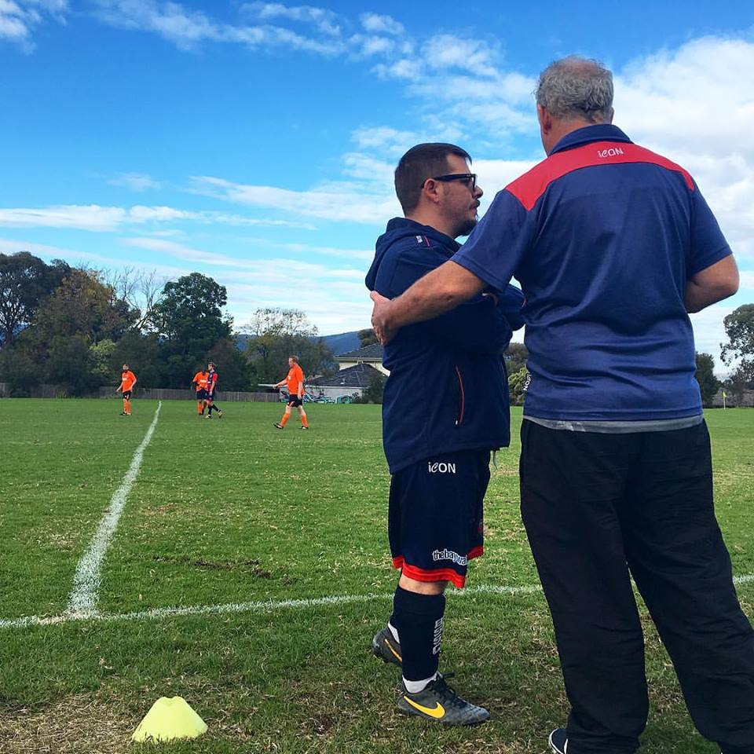

Congratulations

We congratulate Steven D’Urso for winning Best and Fairest for the Premier League across all the VCFA teams.

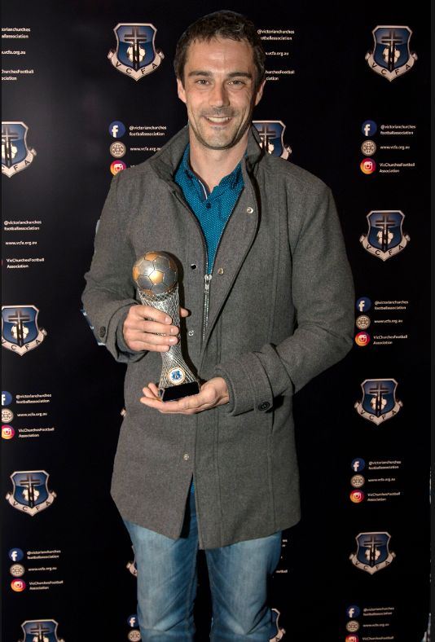
And congratulation to all the players who polled votes

Prem Men | Prem Women | Reserves | Div 5
Steven D’Urso | Heidi D’Urso | Anant Mattoo | Andrew Davy
Richard Brown | Lorna Keegan | Raymond Ternes | Liam Brimmer
Kyle Chandler | Joanna Fitopoulos | James Mason | Matthew Foye
Andrew Dodson | Chanrotha Vinh | Daniel Smith | Rick Beekman
Zach Barmby | Samantha Sumsion | John Bucedi | John Bucedi
James Mason | Eva Orlowski-Oliver | James Sporton | James Mason
Max Edwards | Ayen Anyieth | William Parnell | Glen Brown
Chis Jaques | Jillian Gommers | Stephen Toivonen | Nicholas King
Silas Fisher | Jessica Murphy | Corey Flanagan | Julian Pulford
 | Anne-Marie Ternes | Jeffrey Wortman | Mark Eaton
 |  | Paul Sanhueza
 |  | Rick Beekman
Milestones

Longevity is a sign of a great club.

We are proud of the members who continue to return and represent our club

We wish to congratulate the following people on their milestone years:

10 Years

Ben Crawford
Stuart Oliver
Glen Brown
Mark Ellison
Sarah McCrae

15 Years

Paul Sanhueza
Samantha Sumsion
Liam Brimmer

20 Years

Steven D’Urso
Mark Murphy

“Mere longevity is a good thing for those who watch Life from the side lines. For those who play the game, an hour may be a year, a single day's work an achievement for eternity.” Helen Hayes

Family Values

Congratulations to the following families:

Births

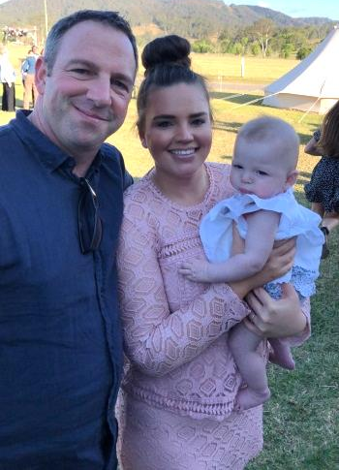
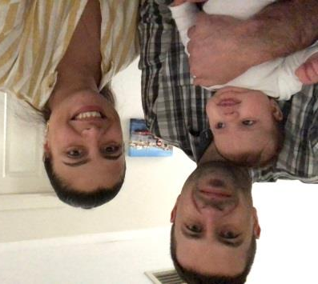
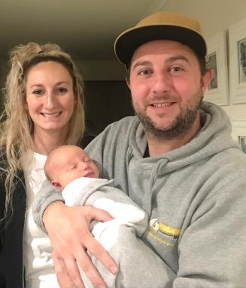

9 May 2019 | 15 May 2019 | 2 August 2019 | 2 August 2019 | 16 December 2017 | 21 April 2018 | 14 April 2018
Mark and Ashlee | Pete and Sarah | Stephen and Veronica | Lorna Brick | Veronica Castro | Phuong Nguyen
welcome baby | welcome baby | welcome baby | welcome baby | & | & | &
Lennox Graham Eaton | Holly Ellie Wiersema | Matilda Maria Castro Toivonen | Matilda Maria Castro Toivonen | Joseph Keegan | Stephen Toivonen | Kyle Chandler

With Thanks to Our Sponsors

Major Sponsors


Speak to any of the committee members about how our sponsors can help with any of your needs. Feel free to mention your association with the Bayswater Strikers Soccer Club when speaking to our great Sponsors.

Minor Sponsors


With Thanks to Our Sponsors


Back in Motion - Bayswater
Physiotherapy & Pilates
9a/348 Mountain Highway, Wantirna VIC 3152
Ph 03 9720 3007
*Offering 10% off every visit as a member of Bayswater Strikers Soccer Club


Busybodies Health & Fitness Centre
29 Erica Avenue, Boronia VIC 3155
Ph 03 9762 2222
*Offering $12.50/week corporate rates as a member of Bayswater Strikers Soccer Club.

Player Sponsors

Burstin Partners Pty Ltd
Accountants and Tax Agents
PO Box 187, Elsternwick VIC 3185
Ph) 03 9523 1133

Bayswater Strikers Soccer Club would like to thank all the players, spectators, families and friends who come down to our games each week and run the lines, act as marshal, help in the canteen and bar, take photos, set up and pack up, cheer on the players and support our club.

Without you, none of this would be possible.

